Message to all EMSA Members:
In 2014 FIFA officially allowed the wearing of religious headgear by players. As with all uniform requirements (Law 4 of FIFA Rules of the Game) the headgear cannot be dangerous to the person who is wearing it or the other players on the field.
Law 4 – Section 4
Other equipment Non-dangerous protective equipment, for example headgear, facemasks and knee and arm protectors made of soft, lightweight padded material is permitted as are goalkeepers’ caps and sports spectacles.
Head Covers Where head covers (excluding goalkeepers’ caps) are worn, they must:
• be black or the same main colour as the shirt (provided that the players of the same team wear the same colour)
• be in keeping with the professional appearance of the player’s equipment
• not be attached to the shirt
• not be dangerous to the player wearing it or any other player (e.g. opening/ closing mechanism around neck)
• not have any part(s) extending out from the surface (protruding elements)
The following are examples of sport hijabs and turbans which are approved by FIFA and Canada Soccer.
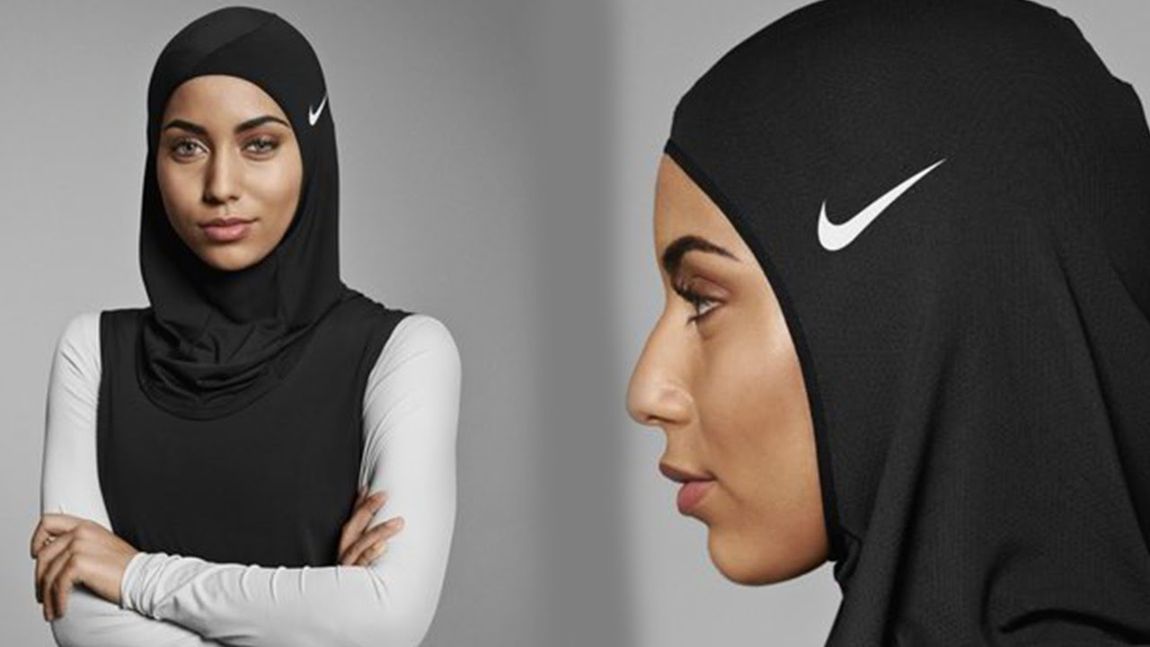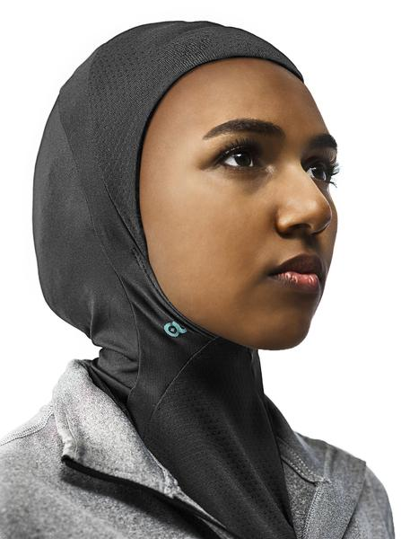
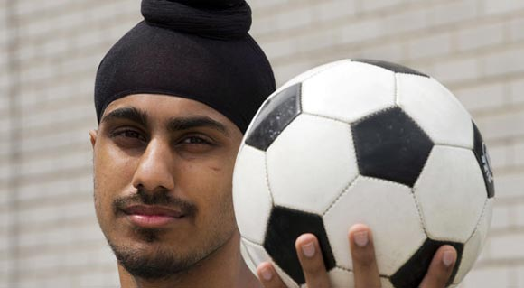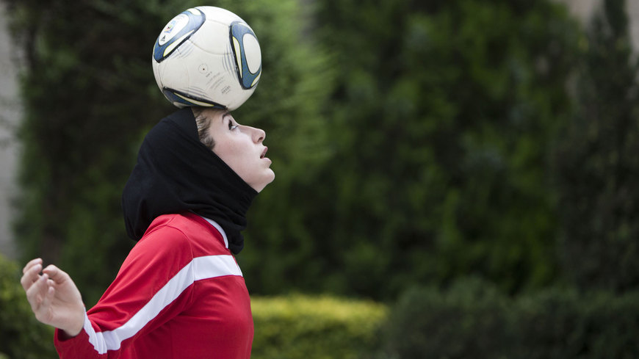

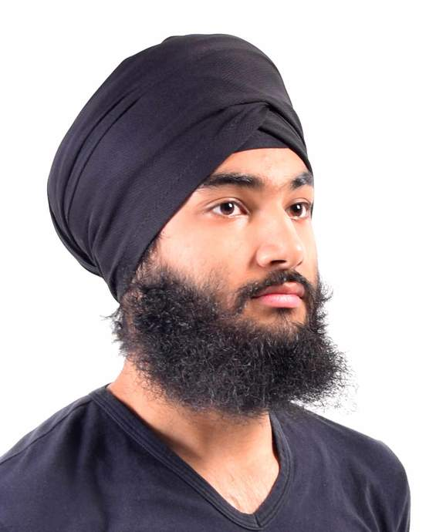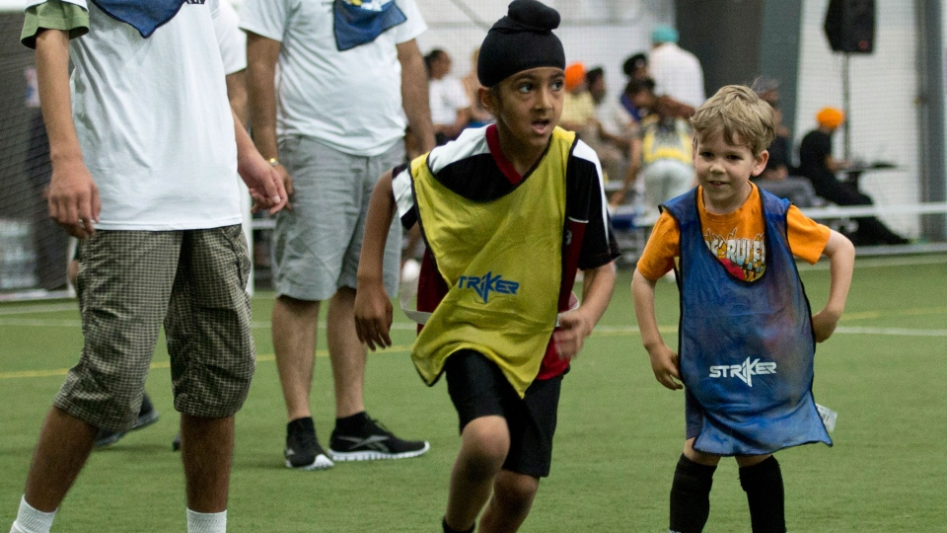

Match Officials who have questions should direct them to Matt McCready, District Referee Coordinator.

